Syllabus Math 3
Karen Petcher
2019-2020
Email: kpetcher@rsu14.org
Phone: (207) 892-1810 ext. 3221

COURSE OUTLINE: The following topics will be covered this year:
Unit 1- Review-Angles and Basic Figures, Triangles, and Quadrilaterals
Unit 2- Parallel and Perpendicular Lines Review
Unit 3- Similarity
Unit 4- Trigonometry
Unit 5- Polyhedrons
Unit 6- Circles
Unit 7- Functions
Unit 8- Variation and Graphs
Unit 9- Linear Functions
Unit 10- Sequences

REQUIRED MATERIALS: a folder, Scientific calculator, writing utensils,
and a notebook (I will provide)- You can use your notebook on any summative assessment if you have an 80%/ 2.5 for a formative homework grade.

GENERAL INFORMATION: Proper classroom behavior is expected at all times. Be respectful of others. Students are expected to be on time for class, seated, and prepared for the start of class with required materials. Cell phones are not to be used in class. All WHS rules and policies must be followed.

EXTRA HELP: I will be available Mondays and Thursdays from 2:00 to 2:40 in room 221. In addition, extra help may be accessed in the Math Lab.

GRADING:

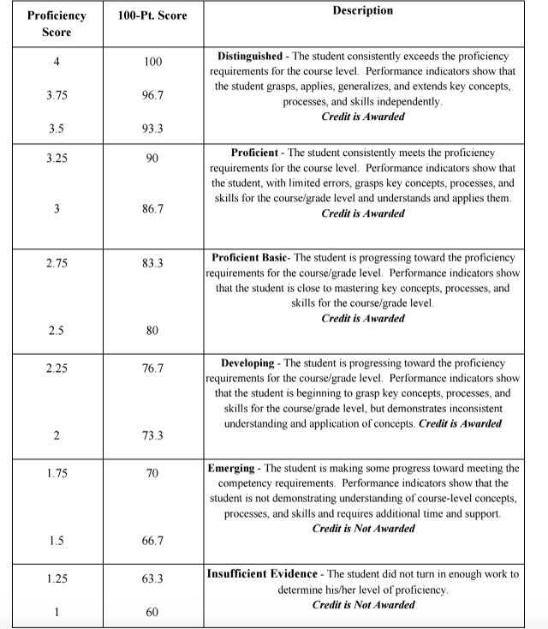

GRADING: Grades will be comprised of 90% summative and 10% formative. For the summative grade tests will be worth 60% and quizzes will be worth 30%. Classwork and homework will be considered in your HOW grade. Once a week one of these assignments will be collected and graded and these assignments will make up your formative grade for the quarter.

All late work for a unit must be passed in before the unit is completed.

In order to be able to retake an assessment students need to make corrections on the first assessment and they must have an 80/ 2.5 for a formative grade. Students have two weeks from the date an assessment is given to retake it.

Student Information will be updated approximately every two weeks on Infinite Campus. Progress reports will be given out halfway through the quarter and report cards will go out at the end of each quarter. At any of these times I will call home or e-mail parents of failing students.

*This syllabus is subject to change at the teacher’s discretion.

