Syllabus Honors PreCalculus
Ms. Petcher
2019- 2020
Email:kpetcher@rsu14.org
Phone: (207)- 892-1810 ext. 3221

PREREQUISITE: successful completion of Algebra 1, Geometry, Algebra 2, and FST.

COURSE OUTLINE: PreCalculus is taught from the University of Chicago School Mathematics Project textbook. The content and questions of this course integrate the major ideas for mathematics needed to be successful in Calculus.

The following topics will be covered this year:

1st Quarter 2nd Quarter

Essential Topic Review Functions, Equations, and Inequalities

Analyzing Functions Integers and Polynomials

3rd Quarter 4th quarter

Algebraic Fractions and Identities Complex Numbers

Derivatives Polar Coordinates and Polar Graphs

REQUIRED MATERIALS: 3 ring binder or folder, writing utensils, covered PreCalculus book, Scientific or graphing calculator

GENERAL INFORMATION: Proper classroom behavior is expected at all times. Be respectful of others. Students are expected to be on time for class, seated, and prepared for the start of class with required materials. Cell phones are not to be used in class. All WHS rules and policies must be followed.

GETTING HELP: I will be available Mondays and Thursdays from 2:00 to 2:40 in room 221. In addition, extra help may be accessed in the Math Lab.

GRADING: Grades will be comprised of summative 90% and formative 10%. For the summative component tests will be worth 60% and quizzes will be worth 30%. For the formative grade classwork and homework will be considered in your HOW grade. Once a week one of these assignments will be collected and graded and these assignments will make up your formative grade for the quarter.

HOMEWORK: Homework will be assigned every class and due the next class. Homework is an extremely important tool in the study of mathematics. It is important to practice math skills and new concepts.

*Missing assignments may be turned in late for a score of an 86.7/3.0.

Students must average an 80/2.5 homework grade to be able to retake an assessment. Homework cannot be made up after an assessment is given. Students have two weeks from the date an assessment is given to retake it.

*This syllabus is subject to change at the teacher’s discretion.

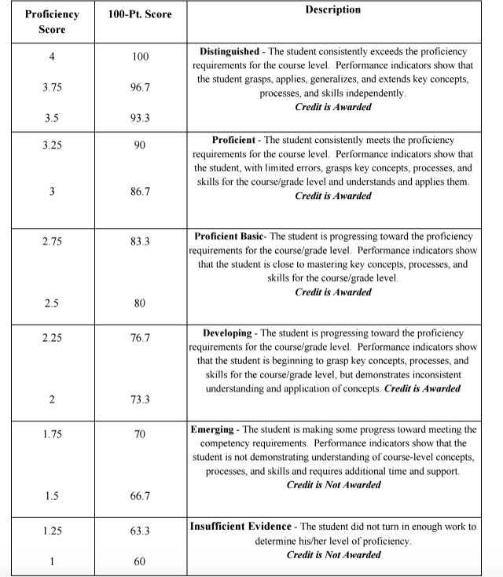

*This syllabus is subject to change at the teacher’s discretion.

